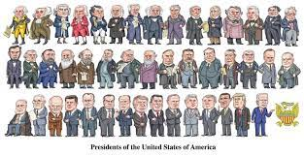
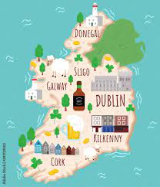
Year 14 A2 History Revision Guide

SUBJECT | HISTORY | HISTORY
Examination Unit Title | Unit 1: (HAAHY11)  Option 5: American Presidents 1901 -2000 | Unit 2: (AAHY21)  Option 5: Partition of Ireland 1900-1925
Examination Board | CCEA | CCEA
Examination Date | Thursday 23rd May (AM) | Friday 7th June (PM)
Examination Length | 1 hour 15 min | 2 hour 30 min
Marks available | 40 | 80
What learners need to know  Topics to revise | - An emerging international presence: Theodore Roosevelt and Woodrow Wilson, 1901–20  - The passive presidents: Harding, Coolidge and Hoover, 1921–32  - The New Deal: FDR, the Great Depression and World War II, 1933–45  - The ‘Imperial Presidency’: Truman, Eisenhower and Kennedy, 1945–63  - The limits of presidential power: Johnson and Nixon, 1963–73  - Watergate: the presidency weakened – Nixon, Ford and Carter, 1972–80  - ‘Morning in America’: recovery under Reagan, Bush and Clinton, 1981–2000 | - The crisis over the Third Home Rule Bill up to September 1914  - Political developments 1914–18  - Political developments 1919–23  - Northern Ireland 1921–25
Specification | GCE  https://ccea.org.uk/downloads/docs/Specifications/GCE/ | GCE  https://ccea.org.uk/downloads/docs/Specifications/GCE/
Departmental Resources to support revision | - eGUIDE  - Revision Notes  - Timed Essays  - CCEA Student Guide  - Past Paper Questions and Mark Schemes | - eGUIDE  - Revision Notes  - Timed Essays  - CCEA Student Guide  - Past Paper Questions and Mark Schemes
External websites to support revision | https://ccea.org.uk/post-16/gce/subjects/gce-history-2019 | https://ccea.org.uk/post-16/gce/subjects/gce-history-2019
Past Paper Questions and Mark Schemes | Past Papers & Mark Schemes | CCEA | Past Papers & Mark Schemes | CCEA

