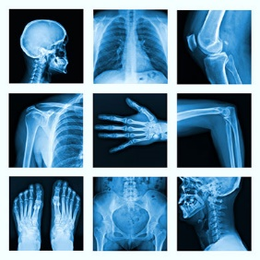
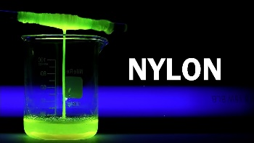
Yr14 Life & Health Science Revision Guide

SUBJECT | Life & Health Science | Life & Health Science
Examination Unit Title | Unit 2:  Organic Chemistry | Unit 3:  Medical Physics
Examination Board | CCEA | CCEA
Examination Date | 5th June 2024 (PM) | 12th June 2024 (AM)
Examination Length | 1 hour 45 minutes | 1 hour 45 minutes
Marks available | 100 | 100
What learners need to know  Topics to revise | - Nomenclature, structure and isomerism in organic compounds  - Hydrocarbons – alkanes  - Hydrocarbons – alkenes  - Alcohols  - Polymers  - Spectroscopic techniques  - Making and purifying organic compounds – the preparation of aspirin  - Making nylon | - Physiological measurements to monitor health  - Diagnostic imaging techniques  - Medical uses of radiation
Specification | https://ccea.org.uk/post-16/gce/subjects/gce-life-and-health-sciences-2016 | https://ccea.org.uk/post-16/gce/subjects/gce-life-and-health-sciences-2016
Departmental Resources to support revision | - Topic Booklets  - Revision Guides  - Past Paper Questions and Mark Schemes | - Topic Booklets  - Revision Guides  - Past Paper Questions and Mark Schemes
Past Paper Questions and Mark Schemes | https://ccea.org.uk/post-16/gce/subjects/gce-life-and-health-sciences-2016/past-papers-mark-schemes | https://ccea.org.uk/post-16/gce/subjects/gce-life-and-health-sciences-2016/past-papers-mark-schemes

