SUBJECT | BIOLOGY | BIOLOGY | BIOLOGY
Examination Unit Title | Unit 1:  Molecules and Cells | Unit 2:  Organisms and Biodiversity | Unit 3:  Practical Skills in Biology
Examination Board | CCEA | CCEA | CCEA
Examination Date | Friday 10th May (PM) | Thursday 23rd May (AM) | Wednesday 29th May (AM)
Examination Length | 1 hour 30 mins | 1 hour 30 mins | 1 hour
Marks available | 100 | 100 | 60
What learners need to know  Topics to revise | - Molecules  - Enzymes  - Viruses  - Cells  - Cell physiology  - Continuity of cells  - Tissues and organs | - Transport and exchange mechanisms  - The principles of of exchange and transport  - Gaseous exchange  - Transport in plant and transpirtation  - Circulatory system  - Adaptations of organisms  - Biodiversity  - Human impact on biodiversity | - Practical skills written exam
Specification | GCE Biology Specification | GCE Biology Specification | GCE Biology Specification
Departmental Resources to support revision | - Topic Booklets  - Revision Guides  - Topic past paper booklets  - Past Papers and Mark Schemes | - Topic Booklets  - Revision Guides  - Topic past paper booklets  - Past Papers and Mark Schemes | - Revision Guides  - Topic past paper booklets  - Past Papers and Mark Schemes
External websites to support revision | GCE Biology CCEA | GCE Biology CCEA | GCE Biology CCEA
Past Paper Questions and Mark Schemes | CCEA Biology Past Papers and Mark Scheme | CCEA Biology Past Papers and Mark Scheme | CCEA Biology Past Papers and Mark Scheme
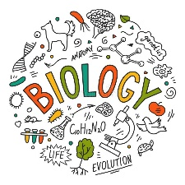
Year 13 AS Biology Revision Guide

