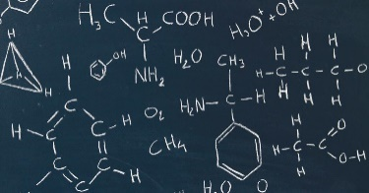
Yr13 Life & Health Science Revision Guide

SUBJECT | Life & Health Science | Life & Health Science
Examination Unit Title | Unit 2:  Human Body Systems | Unit3:  Aspects of Physical Chemistry in Industrial Processes
Examination Board | CCEA | CCEA
Examination Date | 19th May 2024 (PM) | 29th May 2024 (PM)
Examination Length | 1 hour 30 minutes | 1 hour 30 minutes
Marks available | 75 | 75
What learners need to know  Topics to revise | - Cardiovascular system  - Respiratory system  - Respiration  - Homeostatic mechanisms  - Nutrition and physical exercise | - Chemical calculations  - Volumetric analysis  - Energetics  - Kinetics  - Equilibrium  - Industrial processes
Specification | https://ccea.org.uk/post-16/gce/subjects/gce-life-and-health-sciences-2016 | https://ccea.org.uk/post-16/gce/subjects/gce-life-and-health-sciences-2016
Departmental Resources to support revision | - Topic Booklets  - Revision Guides  - Past Paper Questions and Mark Schemes | - Topic Booklets  - Revision Guides  - Past Paper Questions and Mark Schemes
Past Paper Questions and Mark Schemes | https://ccea.org.uk/post-16/gce/subjects/gce-life-and-health-sciences-2016/past-papers-mark-schemes | https://ccea.org.uk/post-16/gce/subjects/gce-life-and-health-sciences-2016/past-papers-mark-schemes

